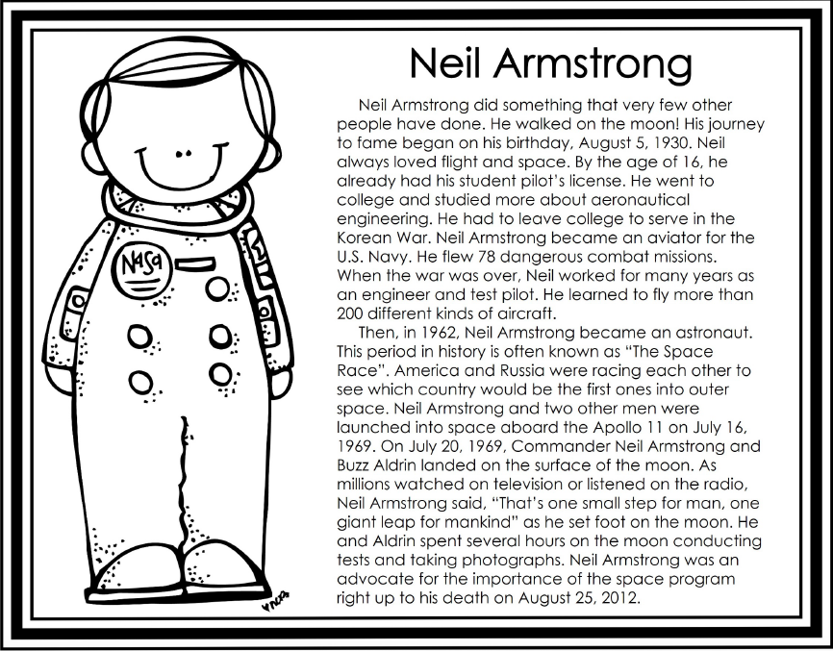

AMI Day #4 Social Studies Name and Number:______________________

Read the following biography. Answer the questions below. Circle your answers and type your response to the last question.

1. How old was Neil Armstrong when he had his student pilot’s license?

A. 16 years old

B. 6 years old

C. 10 years old

2. What branch of the military did he serve?

A. Army

B. Navy

C. Air Force

3. Neil Armstrong became an astronaut. Ture or False

4. Did Neil Armstrong believe the space program was important? Yes or No

5. Would you ever travel in space? Yes or no and why? Use the space below to write your response.