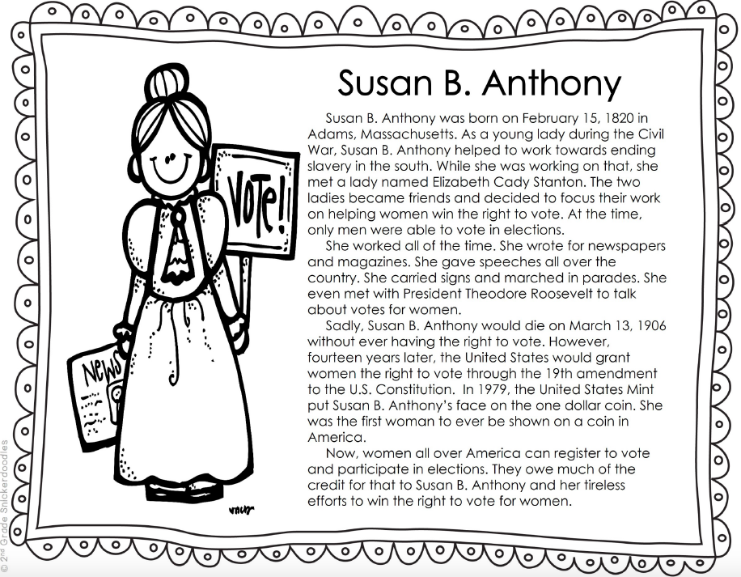

1. About how long ago was Susan B. Anthony born?

A. about 100 years ago.

B. about 200 years ago.

C. about 50 years ago.

2. After meeting Elizabeth Stanton, Susan focused on what important cause?

A. ending slavery

B. public education

C. the right for women to vote

3. Did Susan B. Anthony ever get to vote? Yes or No

4. Which amendment granted women the right to vote?

A. 14th

B. 19th

C. 1st

5. What made her being on a coin special?

A. She was the first woman to shown on a coin.

B. She looked pretty on the coin.

C. The coin was worth a dollar.

AMI Day #4 Social Studies Name and Number:______________________

Read the following biography. Answer the questions below. Circle your answers.